**STAT 614 - HW 3**

**Due:** Thursday, October 1, 2020 in Blackboard (go to the Homework folder under the

Homework/Classwork content area) by 11:59 pm.

**Instructions:** Please type your solutions to these FIVE problems and upload the document as a pdf file in Blackboard. There is only one file to submit for this assignment.

**Notes:** This homework continues our discussions of sampling distributions and statistical inferences, especially using the t-procedures. You will need some concepts that will be discussed in class next week (hence the two-week due date). This is also the last homework before our first exam!!!

1. Triceps skinfold thickness is an upper arm measurement that has been used as a proxy measure of body fat. The table below gives the mean and standard deviations of tricep skinfold thickness (in cm) for two populations of adult males, those with chronic airflow limitation (such as COPD, a type of obstructive lung disease) and those without any airflow limitation. A study comparing tricep skinfold thickness is being planned in these populations using the respective sample sizes (n), also given in the last column of the table.

a. Consider a random sample 𝑦1 , 𝑦2 , 𝑦3 , ... , 𝑦n from the chronic airflow limitation population

with mean 𝜇 and standard deviation 𝜎 as given in the table. What is the standard deviation of the sample mean, 𝑦̅? (Note, this is often called the “standard error” of the mean, especially when an estimate for 𝜎 is used.)

SE = Standard error

b. Assume the Central Limit Theorem is applicable. What does it suggest about potential values of the sample mean, 𝑦̅, the researchers can expect in their study?

The Central Limit Theorem indicates that the shape of sample distribution means will approach normal distribution as the sample of N increasing. (It’s enough if the sample size is greater than 30).

Noted: The central limit theorem states that if you have a population with mean μ and standard deviation σ and take sufficiently large random samples from the population with replacement, then the distribution of the sample means will be approximately normally distributed.

2. A human resources manager for a large company takes a random sample of 50 employees from the company database. She calculates the mean time that they have been employed. She records this value and then repeats the process: She takes another random sample of 50 names and calculates the mean employment time. After she has done this 1000 times, she makes a histogram of the mean employment times. Is this histogram a display of the population distribution, the distribution of a sample, or the sampling distribution of mean?

The HR manager calculates the “mean of random sample” and > 30 times. According to the central limit theorem, which is the sampling distribution of the mean.

3. In most software, the default p-values are computed based on a 2-sided alternative hypothesis (HA: μ ≠ H0: μ0). However, we may want to use a 1-sided alternative in some problems. Hence, we need to be able to compute the correct 1-sided p-values from the reported 2-sided version. Sketch a graph for each of the following to demonstrate that each is the correct procedure. (You can take a photo of your sketch to include in your HW.)



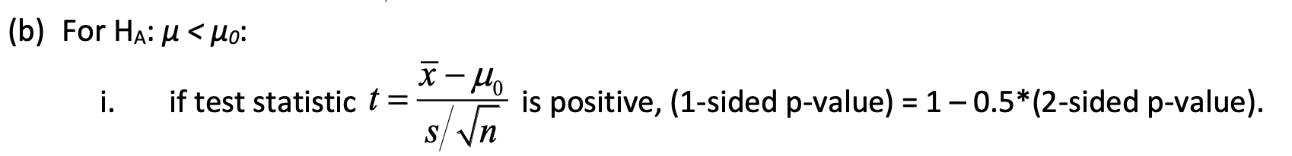

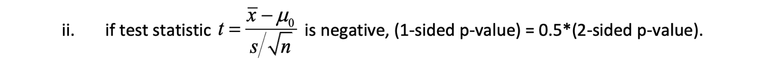

4. Suppose the following statement is made in the conclusions section of a paper: "A comparison of breathing capacities of individuals in households with low nitrogen dioxide levels and individuals in households with high nitrogen dioxide levels indicated that the

re is no difference in means (two- sided p-value = 0.24)."

1. Give a reasonable null and alternative hypothesis that was being tested in this scenario. Carefully define the population parameters of interest being tested.
2. Why is this statement an inaccurate summary of the hypothesis test?
3. Re-write the statement so that it is properly summarizing the results of the hypothesis test.

**References**

The Role of Probability. (n.d.). Retrieved September 20, 2020, from [https://sphweb.bumc.bu.edu/otlt/mph- modules/bs/bs704_probability/BS704_Probability12.html](https://sphweb.bumc.bu.edu/otlt/mph-modules/bs/bs704_probability/BS704_Probability12.html)